# Required Components

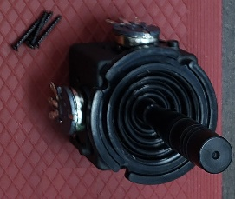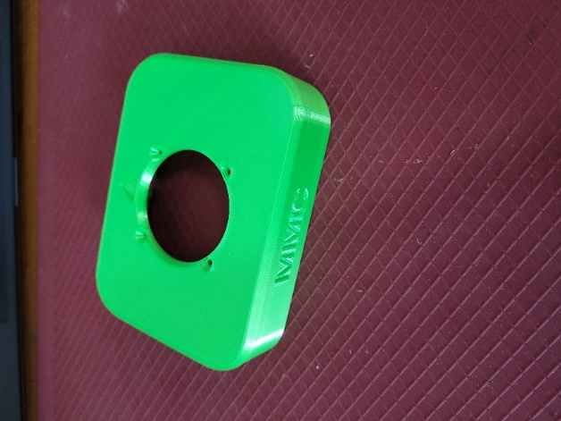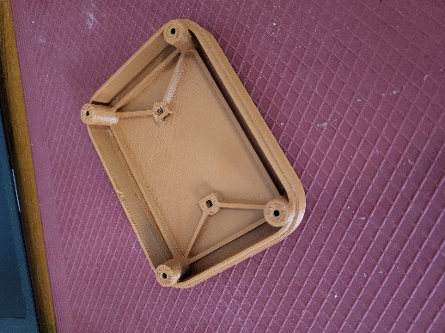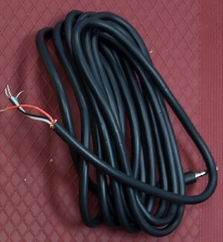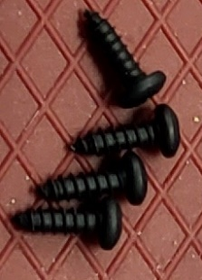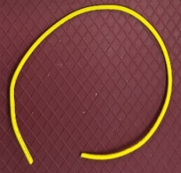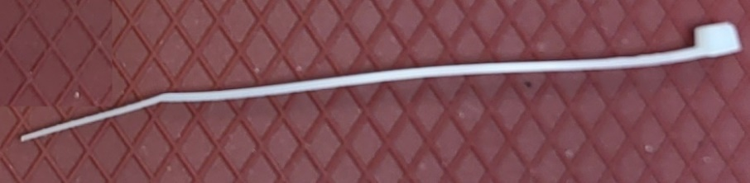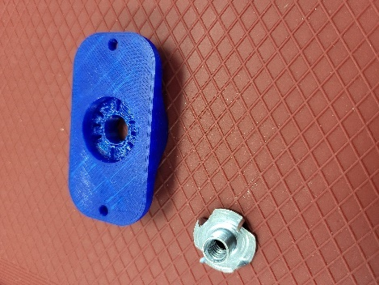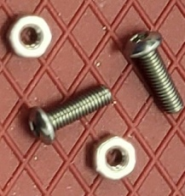

|  |  |
| --- | --- |
| 1. Adafruit mini analog joystick 2. 3D printed enclosure top 3. 3D printed enclosure bottom 4. TRRS Cable 5. #4 3/8” screws x4 6. Extra 24 AWG wire | 1. Ziptie 2. Optional materials (not pictured) 3. 3D printed camera mount adapter 4. Tee nut 5. M3 screws x2 6. M3 nuts x2 |

# Required Tools

* Philips screwdriver
* Soldering iron and solder
* Electrical continuity tester
  + Multimeter
* ¼-20 Hex Bolt (Optional)

# Required Personal Protective Equipment (PPE)

* Safety goggles

# Assembly Instructions

For the next steps, the following diagram and table show the wiring. You should use a multimeter or other continuity tester to confirm which wire corresponds to which part of the plug.

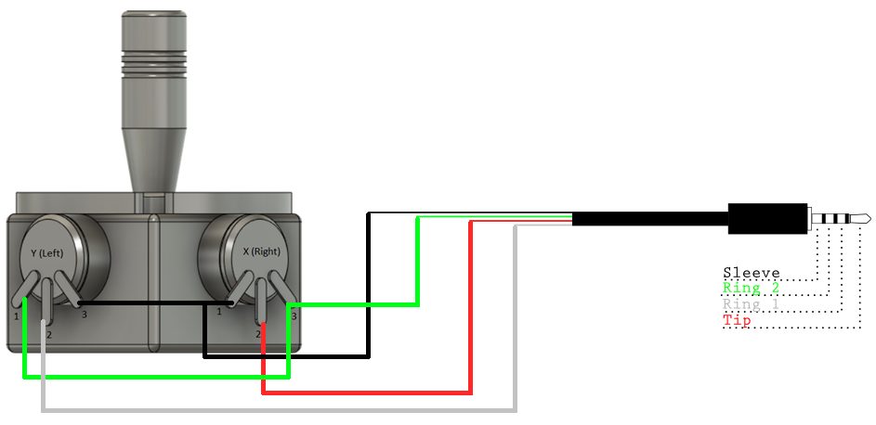

## Step 1

Cut two pieces of wire, one 8cm long, the other 5cm long. Strip 1cm off the ends of both wires.

## Step 2

With the joystick oriented so the corner between the two potentiometers is facing you, connect the inner two potentiometer pins using the 5cm wire and the outer two potentiometer pins using the 8cm wire. Do not solder these connections yet.

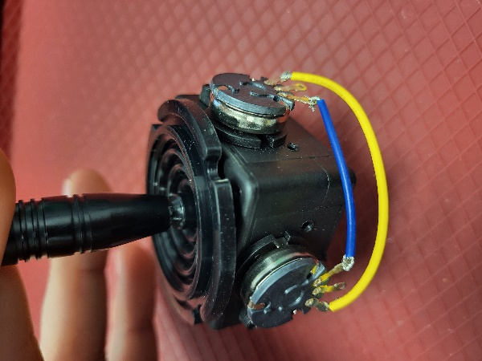

**NOTE**: You can also refer to the debosses in the top enclosure piece for wiring the joystick. (Step 3) Also be sure to keep the joystick oriented with the corner between the two potentiometers facing you.

## Step 3

1. Connect the inner wire of the TRRS cable that connects to the Sleeve (black) to one of the inner potentiometer pins (V) that you just connected with the 5cm wire. Solder the inner potentiometer pins.
2. Connect the inner wire of the TRRS cable that connects to Ring 2 (green) to one of the outer potentiometer pins (G) that you just connected with the 8cm wire. Solder the outer potentiometer pins.
3. Solder the inner wire of the TRRS cable that connects to Ring 1 (white) to the left potentiometer pin (Y). Solder the inner wire of the TRRS cable that connects to the Tip (red) to the right potentiometer pin (X).

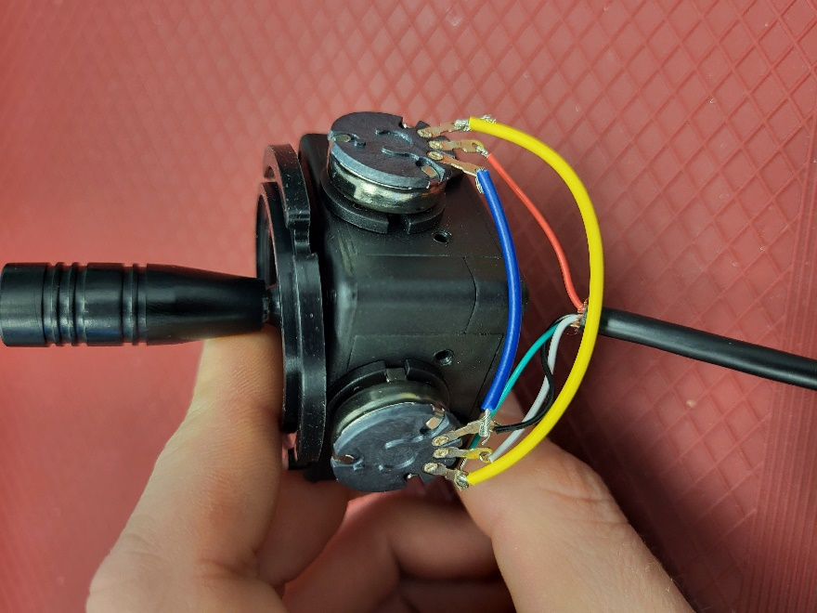

## Step 6

Screw the joystick into the top piece of the enclosure. Ensure the two rectangular debosses on the lid match with the potentiometers on the joystick.

## Step 7

Zip tie the TRRS cable to the cable routing mount on the interior of the top enclosure piece. Cut the excess end of the zip tie off.

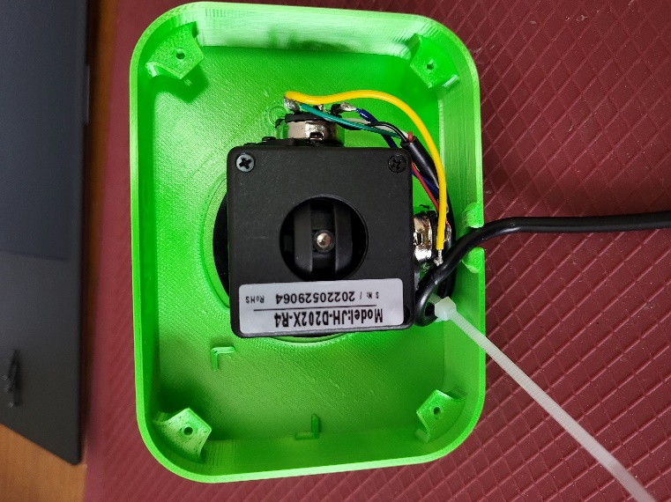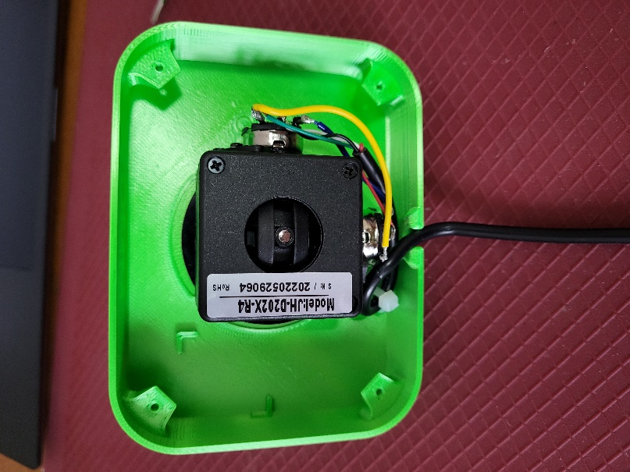

## Step 8

If using the camera mount, slide the M3 nuts into the slots in the bottom enclosure piece. Then using the #4 3/8” screws, screw the bottom enclosure to the top enclosure. Ensure the gap in the edge lines up with the hole in the top enclosure piece for the TRRS cable to route out of. You then have your completed joystick.

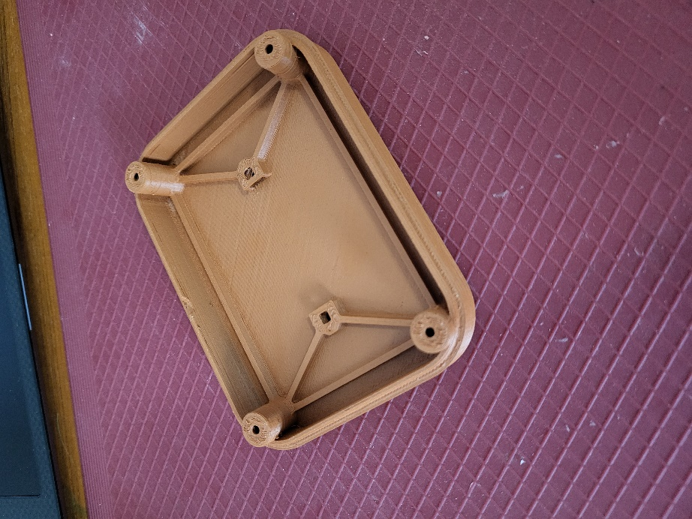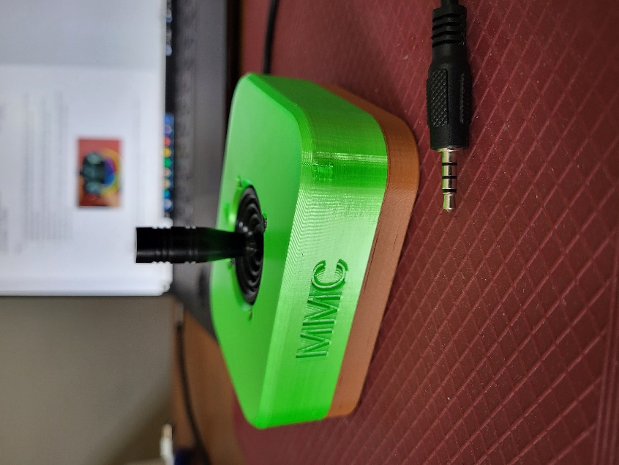

# Testing using an Xbox Adaptive Controller

1. Connect the Xbox Adaptive Controller (XAC) using a USB C cable to the computer.
2. Plug the joystick into either X1 for the left joystick or X2 for the right joystick.
3. If using Windows, open “Set up USB Game Controllers” from the Control Panel. You can find this by searching your computer in the search bar next to the Windows icon.
4. Select the Xbox Adaptive Controller from the list of controllers and go to “Properties”.
5. Move your joystick and observe the movement of the cross hatch in the “Axes” window. Ensure it moves in the proper directions when you move the joystick (the arrow points in the up direction). If not, open up the joystick and check your connections.

Alternatively, you could use the XAC with Steam or an Xbox itself to test that moving the joystick results in the corresponding movements on the controller.

# Optional – Camera Mount

To mount the joystick on a camera mount, the optional Joystick Camera Mount Adapter can be used.

|  |  |
| --- | --- |
| Step 1 Flip the camera mount adapter around to reveal the recess with small slots.  Ensure all supports are removed from the 3D print. | Blue 3D printed part for the camera mount adapter. There are two holes on the sides and one hole in the middle with small slots around it. |

|  |  |
| --- | --- |
| Step 2 Insert the tee nut, lining up the barbs with the small slots in the 3D print. | Blue 3D printed part for the camera mount adapter, with a tee nut sitting inside of it, not fully inserted. |

|  |  |
| --- | --- |
| Step 3 Flip the part around and screw in a ¼-20 hex bolt. | Blue 3D printed part for the camera mount adapter, with a hex bolt being screwed into it. There is a white arrow showing to screw in the hex bolt clockwise. |

|  |  |
| --- | --- |
| Step 4 Tighten the bolt until the tee nut is seated down as far as possible. | Top of the camera mount adapter, with a hex bolt fully screwed into it. There is a white arrow showing to screw in the hex bolt clockwise. Bottom of the camera mount adapter, showing a tee nut fully installed into the 3D print, and sitting flush. There are two arrows pointing down to indicate that the tee nut is all the way down. |

|  |  |
| --- | --- |
| Step 5 Using 2 M3 screws, screw the camera mount adapter to the bottom of the joystick in the two middle holes. | The camera mount adapter screwed into the bottom of the joystick, using two small screws. Both the camera mount adapter and the joystick are light blue. The screws are circled in red. |